1. **Installation of LabVIEW 2015 Service Pack 1 (SP1)**
   1. Installation location: -*Installation Location-*
   2. If LabVIEW 2015 Service Pack 1 (SP1) needs to be downloaded, follow the instructions below. If LabVIEW 2015 Service Pack 1 (SP1) is already downloaded, proceed to step 3.
      1. Open web browser, Type “NI.com” , press Enter.
      2. 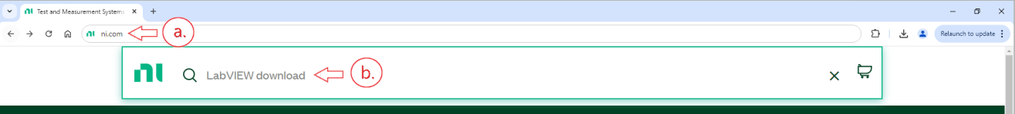Type “LabVIEW download” into the search bar for NI.com and press Enter.
      3. A screenshot of a computer

         Description automatically generatedIn the search results, select “LABVIEW Download”
      4. Verify “Windows” is selected for Supported OS.
      5. Use the drop down to select “2015 SP1” for Version.
      6. Verify “Base, Full, Professional” is selected for Included Editions.
      7. Use the drop down to Select “32-bit” for the Application Bitness.
      8. Verify “English” is selected for Language.
      9. A screenshot of a computer

         Description automatically generatedProceed to press “DOWNLOAD”
      10. A screenshot of a computer

          Description automatically generatedThe Installation files will then be downloaded. A new webpage will load confirming this.
      11. When the download is finished, navigate to the location. Typical default download location is the “Downloads” folder.
      12. Right click on the Zip file that was downloaded.
      13. A screenshot of a computer

          Description automatically generatedSelect “Extract All…”
      14. Select a location for extraction.
      15. Press Extract. A screenshot of a computer

          Description automatically generated
   3. Open the folder titled “2015sp1LV-WinEng” from the installer location.
   4. Right click on “Setup” (Application)
   5. A screenshot of a computer

      Description automatically generatedSelect “Run JCI Elevated”